**LAND APPLICATION OF MANURE**

**A supplement to Manure Management for Environmental Protection**

**MANURE MANAGEMENT PLAN**

**WORKBOOK**

**To Be Completed, Implemented and Retained**

**By All Farmers that Land Apply Manure**

**Description: DEP Logo**

**October 29, 2011**

**MANURE MANAGEMENT PLAN**

**CHECKLIST**

|  |  |  |  |
| --- | --- | --- | --- |
|  | **Manure Management Plan  Page No.** | **Completed or Reviewed** | **Not Needed** |
| **REQUIRED SECTIONS** |  |  |  |
| Contact Information Page | 2 |  |  |
| Operation Information Page | 3 |  |  |
| Environmentally Sensitive Areas Worksheet | 4 |  |  |
| Winter Application Worksheet | 5 |  |  |
| Manure Management Plan Summary | 6 |  |  |
| Farm Map | 7 |  |  |
| Recordkeeping | 11-15 |  |  |
| **Managing Manure Storage in Structures and Stockpiling Areas (If the farm has manure storage)** | 19 |  |  |
| Manure Storage Facilities Worksheet | 8 |  |  |
| Manure Stockpiling and Stacking | 20 of Instructions |  |  |
| **Managing Manure in Pastures (If the farm has pastures)** |  |  |  |
| Pasture Management Worksheet | 9 |  |  |
| **Animal Concentration Areas (If the farm has ACAs) SEE NOTE BELOW** |  |  |  |
| ACA Worksheet | 9-10 |  |  |
| Please note that all farms with crops or ACAs must also have an Agricultural Erosion and Sediment Control Plan meeting the requirements of 25 Pa. Code Chapter 102. Additional information can be obtained from the county conservation district. |  |  |  |

**MANURE MANAGEMENT PLAN**

**CONTACT INFORMATION PAGE**

**(See Page 3 of Manure Management Guidance Instructions)**

Farm Name:

Name of Owner/Operator:

Operation Street Address:

City, State and Zip Code:

Phone number (Home/Barn):

(Cell):

Email Address:

**Name of person preparing the Manure Management Plan**

**(if other than owner/operator)**

Preparer Name:

Preparer Organization:

Street Address:

City, State and Zip Code:

Phone Number (Business):

(Cell):

Email Address:

Date of Development:

Note that the manure management plan must be evaluated by the owner/operator annually and updated when necessary to keep the plan consistent with farm management practices.

## Operation Information Page

**(See Page 4 of Manure Management Guidance Instructions)**

**a. Acres of the operation available for manure application:** Owned Rented

**b. Animals on the operation:**

|  |  |  |
| --- | --- | --- |
| **Animal type** | **Animal # (normal production day)** | **Days on farm per year** |
|  |  |  |
|  |  |  |
|  |  |  |
|  |  |  |

**c. Crop Rotations used on the Operation (use additional pages if necessary)**:

|  |  |  |  |  |  |
| --- | --- | --- | --- | --- | --- |
| **d.** | **Environmentally Sensitive Areas:** | Yes |  | No |  |
|  | Private or public drinking water wells | Yes |  | No |  |
|  | Streams, lakes or ponds | Yes |  | No |  |
|  | Sinkholes | Yes |  | No |  |
|  | Areas of concentrated flow including swales, ditches, gullies, etc. | Yes |  | No |  |
|  | For winter application, above ground inlet to agricultural drainage system | Yes |  | No |  |

All farms containing environmentally sensitive areas must complete the Environmentally Sensitive Areas Worksheet on page 4 and develop a map of environmentally sensitive areas.

|  |  |  |  |  |  |
| --- | --- | --- | --- | --- | --- |
| **e.** | **Winter Application:** Is manure applied during the winter? | Yes |  | No |  |
|  | If yes, you must complete the Winter Application Worksheet on page 5. |  |  |  |  |
|  |  |  |  |  |  |
| **f**. | **Manure Storage Facilities:** Is manure stored in a manure storage facility (concrete tank, metal tank, under building structure, earthen, clay, or synthetic lined pond or lagoon, etc.)? | Yes |  | No |  |
|  | If yes, you must complete the Manure Storage Facilities Worksheet on page 8. |  |  |  |  |
|  |  |  |  |  |  |
| **g.** | **Solid Manure Stockpiling or Stacking:** |  |  |  |  |
|  | Is manure stockpiled or stacked in outdoor areas? | Yes |  | No |  |
|  | If yes, you must meet the requirements in Section 5 - Managing Manure Stockpiling/Stacking Areas on page 18 of the Instructions. |  |  |  |  |
|  |  |  |  |  |  |
| **h.** | **Pasture Areas:** | Yes |  | No |  |
|  | If yes, list acres: Owned Rented |  |  |  |  |
|  | All farms containing pastures must complete the Pasture Management Worksheet on page 9. |  |  |  |  |
|  |  |  |  |  |  |
| **i.** | **Animal Concentration Areas (ACAs):** | Yes |  | No |  |
|  | If yes: Owned  Rented |  |  |  |  |
|  | All farms containing ACAs must complete the ACA Worksheets on pages 9 and 10. |  |  |  |  |

**ENVIRONMENTALLY SENSITIVE AREAS WORKSHEET**

## Use Additional Sheets as Necessary

**(See Pages 6 and 7 of Manure Management Guidance Instructions)**

|  |  |  |  |
| --- | --- | --- | --- |
| **Field**  **Identification** | **Environmentally Sensitive Area (stream, lake, pond, sinkhole, drinking water source, concentrated flow area)** | **Setback or restricted distance** | **Is this setback restricted area shown on the plan map (yes/no)** |
|  |  |  |  |
|  |  |  |  |
|  |  |  |  |
|  |  |  |  |
|  |  |  |  |
|  |  |  |  |
|  |  |  |  |
|  |  |  |  |
|  |  |  |  |
|  |  |  |  |
|  |  |  |  |
|  |  |  |  |
|  |  |  |  |
|  |  |  |  |
|  |  |  |  |
|  |  |  |  |
|  |  |  |  |
|  |  |  |  |
|  |  |  |  |
|  |  |  |  |
|  |  |  |  |
|  |  |  |  |
|  |  |  |  |

**WINTER APPLICATION WORKSHEET**

## Use Additional Sheets as Necessary

**(See Pages 8 and 9 of Manure Management Guidance Instructions)**

|  |  |  |  |  |  |
| --- | --- | --- | --- | --- | --- |
| **Field Identification** | **Type of Manure (from the manure application charts)** | **Winter Season Application Rate** | **Percentage  of Crop Residue** | **Type of Cover Crop (if applicable)** | **Field  Slope Percentage** |
|
|
|  |  |  |  |  |  |
|  |  |  |  |  |  |
|  |  |  |  |  |  |
|  |  |  |  |  |  |
|  |  |  |  |  |  |
|  |  |  |  |  |  |
|  |  |  |  |  |  |
|  |  |  |  |  |  |
|  |  |  |  |  |  |
|  |  |  |  |  |  |
|  |  |  |  |  |  |
|  |  |  |  |  |  |
|  |  |  |  |  |  |
|  |  |  |  |  |  |
|  |  |  |  |  |  |
|  |  |  |  |  |  |
|  |  |  |  |  |  |
|  |  |  |  |  |  |
|  |  |  |  |  |  |
|  |  |  |  |  |  |
|  |  |  |  |  |  |
|  |  |  |  |  |  |
|  |  |  |  |  |  |
|  |  |  |  |  |  |
|  |  |  |  |  |  |

**MANURE MANAGEMENT PLAN SUMMARY**

## Use Additional Sheets as Necessary

**(See Pages 10-12 of Manure Management Guidance Instructions)**

|  |  |  |  |  |  |  |
| --- | --- | --- | --- | --- | --- | --- |
| **Crop Group and Yield (a)** | **Manure Group (b)** | **Application**  **Season (c)** | **Planned**  **Application**  **Rate from**  **C, NBS, PI * (d)** | **Incorporation**  **Timing (e)** | **Commercial Fertilizer Application Rate (f)** | **Fields where this crop group can be used (g)** |
|  |  |  |  |  |  |  |
|  |  |  |  |  |  |  |
|  |  |  |  |  |  |  |
|  |  |  |  |  |  |  |
|  |  |  |  |  |  |  |
|  |  |  |  |  |  |  |
|  |  |  |  |  |  |  |
|  |  |  |  |  |  |  |
|  |  |  |  |  |  |  |
|  |  |  |  |  |  |  |
|  |  |  |  |  |  |  |
|  |  |  |  |  |  |  |

**\***C - The application rate was taken from the charts in Appendix 1. **Page 2 of Appendix 1 contains an explanation and example of how to use the rate charts when filling out this Manure Management Plan Summary.**

NBS - The application rate was calculated using Nutrient Balance Sheet.

PI - The application rate was calculated by a Certified Nutrient Management Planner using the Phosphorus Index.

**No single application can exceed 9,000 gallons. For applications rates greater than 9,000 gallons, the application must be split into multiple applications with no evidence of pooling between applications.**

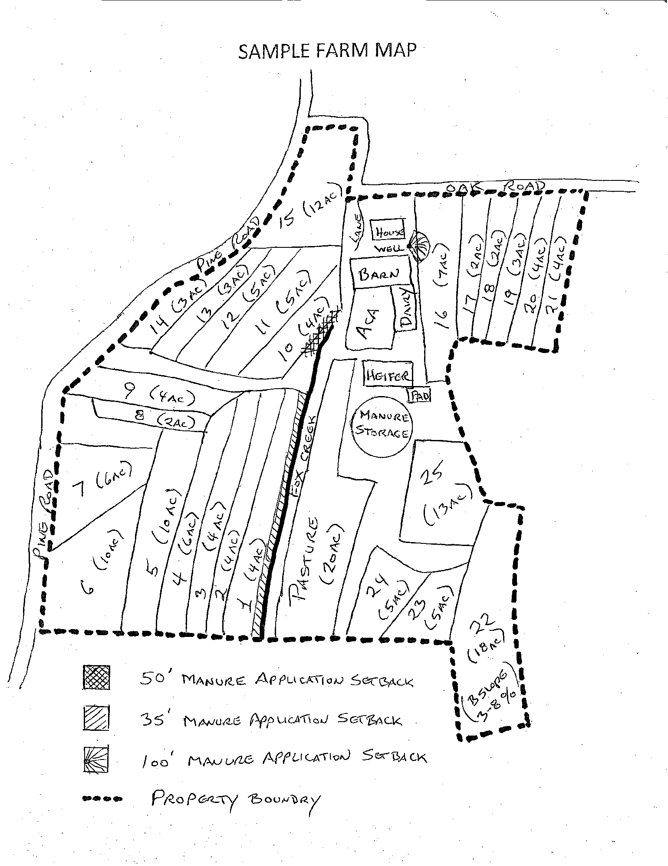

**Manure Storage Facilities (provide for each facility)**

**Use Additional Sheets as Necessary**

**(See Page 18 of Manure Management Guidance Instructions)**

Type of storage(s) (concrete or metal tank, under building structure, earthen or clay or synthetically lined pond or lagoon, exposed concrete pad, roofed solid manure stacking pad, etc.) and year(s) of construction:

Approximate size and volume (for liquid and semisolid manure) of existing manure storage(s), indicate if exposed to precipitation.

Indicate if any additional materials are added to the manure including bedding, agricultural process wastewater (water system overflow, wash water, milkhouse waste, egg wash water, etc.):

Manure storage(s) related practices that need to be installed on the farm to address identified problems (such as inadequate storage volume, leaking facilities, inadequate maintenance, runoff from a stack that directly reaches a water body, etc.) and an implementation schedule (season and year) for installation of the practices:

**NOTE** - If you generate or import agricultural process wastewater at the farm, this wastewater must be included in your manure management plan. On many farms, this wastewater is mixed with manure within the manure storage facility. In that case, there is no separate planning requirement for the agricultural process wastewater. If the agricultural process wastewater is not mixed with manure in the manure storage facility, you should contact the county conservation district or DEP to discuss the process for managing that wastewater.

**PASTURE MANAGEMENT WORKSHEET**

**(See Page 21 of Manure Management Guidance Instructions)**

All pastures on the farm must be listed in the Manure Management Plan and identified on the farm map.

Please identify your pasture management approach below:

I have a grazing plan meeting the requirements of the Natural Resources Conservation Service Pennsylvania Technical Guide Practice Standard 528 for Prescribed Grazing.

I am managing my pastures by maintaining dense vegetation in the pasture throughout the growing season. Dense vegetation means that the pasture is managed to minimize bare spots and to maintain an average vegetation height across the pasture during the growing season at least 3 inches high.

Grazed fields that do not have an NRCS grazing plan which are overgrazed (as defined as not meeting the management requirements described above in check box “2”) need either to be managed to restore dense vegetation or these areas will be defined as Animal Concentration Areas (“ACAs”) and will need to meet the requirements of Section 5 Animal Concentration Areas of this manual.

**ANIMAL CONCENTRATION AREAS WORKSHEET**

**Part 1**

**(See Page 22 of Manure Management Guidance Instructions)**

Some farms may need technical assistance in order to develop and implement BMPs on ACAs. The farmer has until October 29, 2013, to develop the BMPs and no more than 3 years from the date of developing those BMPs, to implement the BMPs. DEP believes that most farms will be able to begin implementation on a much shorter time frame but recognizes that more time may be needed for costly BMPs.

Farmers with ACAs requiring corrective actions need to immediately contact the local conservation district, NRCS, or a private consultant and must document that contact and the time frame for developing and implementing BMPs.

List date contact was made to the assisting agency/party to help in these efforts:

List who was contacted to assist in these efforts:

**ANIMAL CONCENTRATION AREA WORKSHEET**

**Part 2**

**Use Additional Sheets as Necessary**

**(See Page 22 of Manure Management Guidance Instructions)**

|  |  |  |  |  |  |
| --- | --- | --- | --- | --- | --- |
|  | **List Yes if BMP has been implemented and if BMP is planned,  list date for installation** | | | | |
| **Location of ACA (refer to Farm Map)** | **Divert clean water around ACA** | **Direct polluted water to storage or vegetated treatment area** | **Limit access to streams through stabilized crossings and watering areas** | **Limit size of denuded areas** | **Locate area where animals congregate (feed areas, shade, etc.) away from streams** |
|  |  |  |  |  |  |
|  |  |  |  |  |  |
|  |  |  |  |  |  |
|  |  |  |  |  |  |
|  |  |  |  |  |  |
|  |  |  |  |  |  |
|  |  |  |  |  |  |
|  |  |  |  |  |  |
|  |  |  |  |  |  |
|  |  |  |  |  |  |
|  |  |  |  |  |  |
|  |  |  |  |  |  |
|  |  |  |  |  |  |
|  |  |  |  |  |  |
|  |  |  |  |  |  |
|  |  |  |  |  |  |
|  |  |  |  |  |  |
|  |  |  |  |  |  |
|  |  |  |  |  |  |
|  |  |  |  |  |  |
|  |  |  |  |  |  |
|  |  |  |  |  |  |

**LAND APPLICATION OF MANURE**

**A supplement to Manure Management for Environmental Protection**

**RECORDKEEPING FORMS**

**(See Pages 15 through 17 of Manure Management Guidance Instructions)**

**Description: DEP Logo**

**MANURE APPLICATION RATE RECORD**

**JANUARY 1, ______ THROUGH DECEMBER 31, ________**

**Use Additional Sheets as Necessary**

**(See Page 15 of Manure Management Guidance Instructions)**

|  |  |  |  |  |  |  |
| --- | --- | --- | --- | --- | --- | --- |
| **Date** | **Field Identification** | **Acres** | **Manure Group** | **Crop Group** | **Application Rate** | **Notes** |
|  |  |  |  |  |  |  |
|  |  |  |  |  |  |  |
|  |  |  |  |  |  |  |
|  |  |  |  |  |  |  |
|  |  |  |  |  |  |  |
|  |  |  |  |  |  |  |
|  |  |  |  |  |  |  |
|  |  |  |  |  |  |  |
|  |  |  |  |  |  |  |
|  |  |  |  |  |  |  |
|  |  |  |  |  |  |  |
|  |  |  |  |  |  |  |
|  |  |  |  |  |  |  |
|  |  |  |  |  |  |  |
|  |  |  |  |  |  |  |
|  |  |  |  |  |  |  |
|  |  |  |  |  |  |  |
|  |  |  |  |  |  |  |
|  |  |  |  |  |  |  |
|  |  |  |  |  |  |  |
|  |  |  |  |  |  |  |
|  |  |  |  |  |  |  |
|  |  |  |  |  |  |  |
|  |  |  |  |  |  |  |

**CROP YIELD RECORD**

**JANUARY 1, ______ THROUGH DECEMBER 31, _______**

**Use Additional Sheets as Necessary**

**(See Page 16 of Manure Management Guidance Instructions)**

|  |  |  |  |  |  |
| --- | --- | --- | --- | --- | --- |
| **Field Identification** | **Crop Group** | **Date Harvested** | **Yield Goal** | **Actual Yield Harvested** | **Notes** |
|  |  |  |  |  |  |
|  |  |  |  |  |  |
|  |  |  |  |  |  |
|  |  |  |  |  |  |
|  |  |  |  |  |  |
|  |  |  |  |  |  |
|  |  |  |  |  |  |
|  |  |  |  |  |  |
|  |  |  |  |  |  |
|  |  |  |  |  |  |
|  |  |  |  |  |  |
|  |  |  |  |  |  |
|  |  |  |  |  |  |
|  |  |  |  |  |  |
|  |  |  |  |  |  |
|  |  |  |  |  |  |
|  |  |  |  |  |  |
|  |  |  |  |  |  |
|  |  |  |  |  |  |
|  |  |  |  |  |  |
|  |  |  |  |  |  |
|  |  |  |  |  |  |
|  |  |  |  |  |  |

**MANURE TRANSFER RECORD**

**JANUARY 1, ______ THROUGH DECEMBER 31, _______**

**Use Additional Sheets as Necessary**

**(See Page 16 of Manure Management Guidance Instructions)**

|  |  |  |  |  |  |
| --- | --- | --- | --- | --- | --- |
| **Date** | **Name of Importer/Broker** | **Address and Phone Number Importer/Broker** | **Manure Group** | **Amount of Manure Transferred** | **Crop Group and Application Rate** |
|  |  |  |  |  |  |
|  |  |  |  |  |  |
|  |  |  |  |  |  |
|  |  |  |  |  |  |
|  |  |  |  |  |  |
|  |  |  |  |  |  |
|  |  |  |  |  |  |
|  |  |  |  |  |  |
|  |  |  |  |  |  |
|  |  |  |  |  |  |

**MANURE STORAGE FACILITY RECORD**

**MONTHLY INSPECTION FORM**

**Use Additional Sheets as Necessary**

**(See Page 17 of Manure Management Guidance Instructions)**

|  |  |  |  |  |  |
| --- | --- | --- | --- | --- | --- |
| **Storage Name** | **Inspection Date** | **Manure Depth (liquid)** | **Depth from Surface of Manure to Freeboard (liquid)** | **Leak Detection System Inspections. Are there any leaks, overflows, or seepages? Describe.** | **Structural Integrity. Are there cracks, erosion, slope failures, liner deterioration, rodent holes, large vegetation, excessive or lush vegetation, fencing issues, loading area issues? Describe.** |
|  |  |  |  |  |  |
|  |  |  |  |  |  |
|  |  |  |  |  |  |
|  |  |  |  |  |  |
|  |  |  |  |  |  |
|  |  |  |  |  |  |
|  |  |  |  |  |  |
|  |  |  |  |  |  |
|  |  |  |  |  |  |
|  |  |  |  |  |  |
|  |  |  |  |  |  |